Case Report
A young girl with progressive symmetrical erythrokeratoderma and short height
Feroza Fatima, Naseema Kapadia, Maria Farooqi, Maryam Noshad, Sehar Athar, Shahmoona Faisal, Tayyaba Imran

Department of Dermatology, Abbasi Shaheed Hospital, Karachi

Abstract | Progressive symmetrical erythrokeratoderma is an uncommon genodermatosis and is thought to arise due to mutations in the connexin gene. However, genetic heterogeneity has been described. We report a case of progressive symmetrical erythrokeratoderma, with short height.  Key words  Short height, loricrin, progressive symmetrical erythrokeratoderma

Introduction
Erythrokeratoderma is the association of localized hyperkeratotic plaques with overlapping or distinct areas of circumscribed erythema. This clinically and genetically heterogeneous disease group has two major subtypes; erytrokeratoderma variabilis (EKV) and progressive symmetrical erythrokeratoderma (PSEK). PSEK has its onset during early childhood and seems to be inherited as an autosomal dominant trait with incomplete penetrance and variable expressivity. Differentiation of EKV from PSEK can be made by the sharply outlined geographical regions of migratory erythema observed in EKV.
Case report
A 16-year-old girl was brought to Dermatology OPD, Abbasi Shaheed Hospital, Karachi by her parents who were concerned about the rough, dry, and scaly hyperpigmented plaques over both her dorsum of hands and feet, which always became worse during winter season. The girl was born by normal vaginal delivery in local hospital. Birth history was not contributory. Parents only noticed a red scaly plaque over dorsum of right foot that became hyperpigmented with the passage of time.
Address for correspondence
Dr. Feroza Fatima
Department of Dermatology,
Abbasi Shaheed Hospital, Karachi
Ph# 021-34975261, 03009296559
Email: feroza24@gmail.com
Now for the last 3-4 years, she started to develop red irregular plaques bilaterally, symmetrically over her body especially acral areas and over joints that became hyperpigmented later on and static but not migratory.
On examination the skin over the dorsum of both hands was scaly and thickened in a well-demarcated manner, almost like gloves, with the irregular hyperpigmented, hyperkeratotic and fine scaly plaques extending along the medial aspect of the forearm up to the elbows, where it abruptly ended (Figure 1-3). Erythema was appreciated only in 2-3 new progressive lesions of forearms. The palms and soles were only mildly thickened.

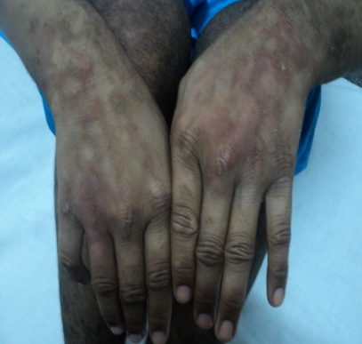
Figure 1 Symmetrical hyperkeratosis with scaling over both dorsum aspect of hands extending medially up to the elbows.

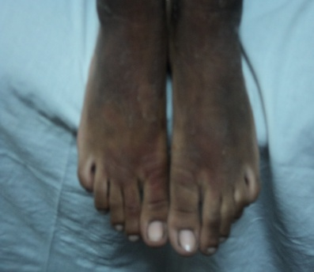
Figure 2 Symmetrical hyperkeratosis with fine scales over feet, up to the knee joints. Soles are clear bilaterally.

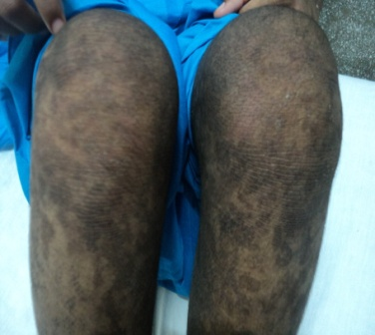
Figure 3 Symmetrical hyperkeratosis with accentuated creases over both knees.
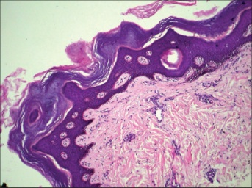
Figure 4 Lamellated hyperkeratosis, intact granular layer, acanthosis, and mild spongiosis, with mild perivascular lymphocytic infiltrate.
Similarly she had hyperkeratotic skin over the dorsum of feet bilaterally and symmetrically, extending up to the knee joints. Few irregular, thickened hyperpigmented plaques were present on the trunk, neck, proximal extremities. Scalp, face, nails, hair and mucosa were normal on cutaneous examination.
General physical examination and systemic examination were normal except her height that was short according to her age.
A biopsy of the lesion on her leg showed sparse superficial perivascular lymphocytic infiltrate in the dermis, with slight epidermal hyperplasia. The epidermis showed acanthosis in some areas, mild focal spongiosis with an intact granular layer and a moderately thickened stratum corneum showing lamellated hyperkeratosis, with parakeratosis being visible only in some fields (Figure 4). On the basis of the clinicopathological correlation, a diagnosis of progressive symmetric erythrokeratoderma (PSEK) was made.
She is under treatment with salicylic acid ointment and a urea-based cream, with marginal improvement.
Discussion
Progressive symmetric erythrokeratoderma is a rare type of erythrokeratodermia inherited in an autosomal dominant fashion in about 50% of the cases. The entity is characterized by non-migratory, erythematous or hyperpigmented, symmetric plaques that are usually distributed on the extremities, buttocks, and sometimes the face. The histology is nonspecific in PSEK. Orthokeratosis, orthohyperkeratosis with focal parakeratosis, a well-preserved granular layer, psoriasiform hyperplasia without thinned suprapapillary plates, and a perivascular infiltrate of lymphocytes in the upper part of the dermis, have all been reported.¹⁻⁵
Progressive symmetric erythrokeratoderma is clinically different from erythrokeratoderma variabilis (EKV) first described by Mendes da Costa) its closest differential diagnosis, by well-demarcated non-migratory erythematous plaques in contrast to the migratory plaques seen in the latter.⁶ The erythema component of the erythrokeratoderma seems not to be relevant to populations with type IV-VI skin, as the erythema is not easily appreciated on dark skin.
The candidate gene for EK-related mutation is connexin (CON).⁷⁻¹⁰ CON mutations result in disturbed cell-cell communication due to faulty gap junctions. CON mutations have been identified in both the PSEK and EKV families, including CON 31 (GJB3) and CON 30.3 (GJB4).¹⁰
On the other hand, some families have no CON mutations at all.¹¹ The available data suggests some genetic heterogeneity of PSEK. Recent investigations suggest that the LOR mutation might be due to the occurrence of the Vohwinkel's syndrome in the same family, and PSEK was not associated with the LOR mutations at all.⁷
We are unable to explain the short height in our case, although there are only scattered reports of neurological involvement in the erythrokeratodermas.¹⁻⁵ Therefore, the occurrence of short height may just be a coincidence. Further studies are needed to come to a final conclusion.
Topical emollients and salicylic acid ointment, along with urea, was the recommended treatment, but was only of marginal benefit in the present patient.¹² Etretinate and acitretin have been tried by others with varying success.¹³
References
- Ruiz-Maldonado R, Tamayo L, del Castillo V, Lozoya I. Erythrokeratodermia progressiva symmetrica: Report of 10 cases. Dermatologica. 1982;164:133-41.
- Chu DH, Arroyo MP. Progressive and symmetric erythrokeratoderma. Dermatol Online J. 2003;9:21.
- Ghorpade A, Ramanan C. Progressive symmetric erythrokeratoderma. Indian J Dermatol Venereol Leprol. 1995;61:116-7.
- Khoo BP, Tay YK, Tan SH. Generalized erythematous plaques. Progressive symmetric erythrokeratodermia (PSEK) (erythrokeratodermia progressiva symmetrica). Arch Dermatol. 2000;136:665-8.
- Storck H, Schwarz K, Schnyder UW. Krankendemonstration in der Dermatologischen Klinik Zürich. Arch Klin Exp Dermatol. 1964;219:946-1032.
- Ishida-Yamamoto A, McGrath JA, Lam H et al. The molecular pathology of progressive symmetric erythrokeratoderma: A frameshift mutation in the loricrin gene and perturbations in the cornified cell envelope. Am J Hum Genet. 1997;61:581-9.
- Wei S, Zhou Y, Zhang TD et al. Evidence for the absence of mutations at GJB3, GJB4 and LOR in progressive symmetrical erythrokeratodermia. Clin Exp Dermatol. 2011;36:399-405.
- Richard G, Whyte YM, Smith L et al. Linkage studies in erythrokeratodermias: Fine mapping, genetic heterogeneity, and analysis of candidate genes. J Invest Dermatol. 1997;109:666-71.
- Richard G, Brown N, Rouan F et al. Genetic heterogeneity in erythrokeratodermia variabilis: Novel mutations in the connexin gene GJB4 (Cx30.3) and genotype-phenotype correlations. J Invest Dermatol. 2003;120:601-9.
- Van Steensel MA, Oranje AP, van der Schroeff JG et al. The missense mutation G12D in connexin30.3 can cause both erythrokeratodermia variabilis of Mendes da Costa and progressive erythrokeratodermia of Gottron. Am J Med Genet A. 2009;149A:657-61.
- Akman A, Masse M, Mihci E et al. Progressive symmetrical erythrokeratoderma: report of a Turkish family and evaluation for loricrin and connexin gene mutations. Clin Exp Dermatol. 2008;33:582-4.
- Lodén M. The clinical benefit of moisturizers. J Eur Acad Dermatol Venereol. 2005;19:672-88.
- Tàmoyo L, Ruiz-Maldonado R. Oral retinoid (RO 10-9359) in children with lamellar ichthyosis, epidermal hyperkeratosis and symmetrical progressive erythrokeratodermia. Dermatologica. 1980;161:305-14.

Article withdrawn
‘Angiolymphoid hyperplasia with eosinophilia’ published as ‘Short Communication’ in the Journal of Pakistan Association of Dermatologists, October-December issue, 2012 (page 387-88) was mistakenly republished as ‘Short Communication’ in the January-March issue, 2013 (page 108-110). Acknowledging this mistake, it is hereby withdrawn from the January-March, 2013 issue.

