Original Article
Role of tissue expansion in hair restorative surgery
Muhammad Ahmad*, Humayun Mohmand**

*Plastic, Reconstructive & Hair Restorative Surgeon, Islamabad, Pakistan
** Cosmetic & Hair Restorative Surgeon, Hair Transplant Institute, Islamabad, Pakistan

Abstract | Objectives To share the experience of tissue expansion used in hair restoration.  Materials and methods The study was carried out from June 2005 to June 2010. In the 1st stage, tissue expander was laced under the normal skin adjacent to the defect. Serial expansions were performed twice weekly. In the 2nd stage, the tissue expander was removed, the defect was excised and adjacent flaps were used to reconstruct the defect. The patients were followed up regularly.  Results A total of 16 patients underwent reconstruction with a male to female ratio of 2.2:1. Postburn scar was the most frequent cause (43.8%). The mean expansion time was 33.6 days with average fill volume of 193.4ml.  Conclusion Tissue expansion is a safer technique and should be used as a primary procedure prior to hair transplantation in patients with large scalp defects.  Key words  Hair restoration, burn scar, tissue expansion.

Introduction
Tissue expansion has undergone many advances since first used by Neumann.¹ It requires the placement of a silicone balloon filled by serial injections of sterilized solution over a period of weeks to months. It is widely used in reconstructive surgery for the reconstruction of various defects and deformities.²⁻⁴ Tissue expansion has been used in hair restorative surgery specially in postburn alopecia.^{5,6} Similarly pre-expanded scalp flaps (scalp reduction) have also been mentioned in the literature.⁷⁻⁹ The tissue expansion provides the hair-bearing skin after the excision of the non-hair bearing/scarred/burned skin. Although the follicular unit grafting can be performed but usually the density of the grafted hair is not adequate and depends on the condition of the recipient skin. In most of the cases, there is loss of fatty layers of scalp or the skin grafted areas of the scalp are generally not very good recipient areas ¹⁰. The placement of tissue expanders, volume and shape depend on the geometry of the defect and the available hair-bearing areas. Precise pre-operative planning is, therefore, of utmost importance.
The aim of the study was to share the experience of hair restoration using the tissue expansion.
Address for correspondence
Dr. Muhammad Ahmad,
Plastic, Reconstructive, Hand & Hair Restorative Surgeon,
Hair Transplant Institute, 2nd floor, Zahoor Plaza, E-38, Jinnah avenue, Blue area, Block-A, Islamabad, Pakistan
Email: plasticsurgeon999@yahoo.com
Patients and methods
The study was conducted from June 2005 to June 2010 in the private hair restoration/plastic surgery clinic. The patients of all ages undergoing hair restoration by using tissue expansion were included. The patients undergoing primary excision and closure were not included. The tissue expanders were approached through the scarred area and were placed under the normal skin close to the defect under general anesthesia. Careful dissection was performed and proper hemostasis of the pocket was ensured. A drain was placed which was removed after 48-72 hours. Oral Second generation cephalosporins were administered pre-operatively which were continued for 8-10 days post-operatively.
Tissue expansion was started on 10th post-operative day. The expanders were filled using a fine gauged needle to the bearable discomfort/pain level of the patient. The tissue expanders were filled twice weekly. Once the adequate expansion was achieved, no filling was done for 24-48 hours prior the second stage. The procedures were performed under general anesthesia. The defects were excised and the rotation flaps were used to reconstruct the defects. The patients were followed up regularly. Complications were noted and managed accordingly.
Results
Sixteen patients underwent tissue expansion with male to female ratio of 2.2:1 (Figure 1). The average age was 31.4 years (range, 24-42 years) in males and 28.8 years in females (range, 20-56 years). Postburn scar alopecia was the commonest cause (43.8%) followed by post-traumatic scar (25%), post-traumatic skin grafts (Table 1). Two tissue expanders were used in most of the cases (62.5%) and three tissue expanders were used in 25% cases whereas single tissue expander was used in only two
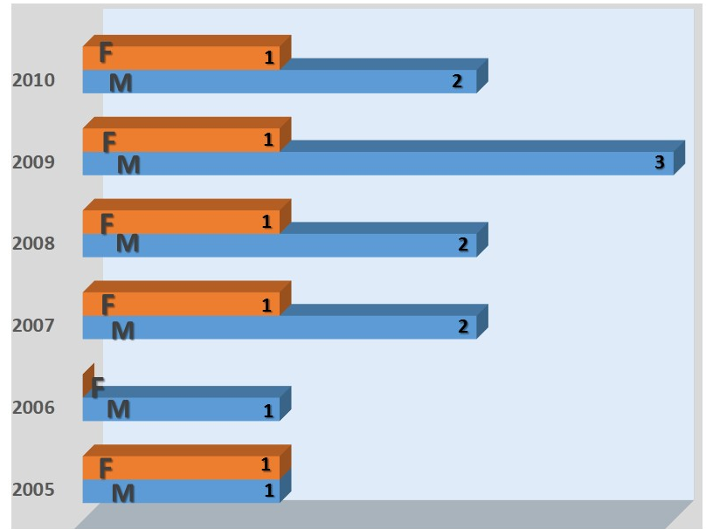
Figure 1 Number of cases requiring tissue expansion.

Table 1 Causes of using tissue expansion.
Etiology | Male | Female
Burns | 5 | 2
Post-traumatic scar | 3 | 1
Post-traumatic skin graft | 1 | 1
Androgenic alopecia | 1 | 0
Infection | 1 | 1

Table 2 Complications of using tissue expansion.
Complication | Number
Discomfort/Pain | 6
Temporary hair loss | 3
Slight leakage | 1
Infection | Nil
Rupture | Nil
Displacement | Nil
cases. The average fill volume was 193.4 ml (range, 100-320 ml). The mean expansion time was 33.6 days (range, 28-56 days). No case of tissue expander infection was seen. Slight leakage was found only in one case (Table 2).
Case 1
A 24-year-old female presented with postburn alopecia involving the right side of scalp (frontal, temporal and part of parietal area). She underwent tissue expander placement in the first stage. A single tissue expander of 320 ml was used which was serially inflated. The final surgery was performed on 40th day. The scarred tissue was excised and the defects were

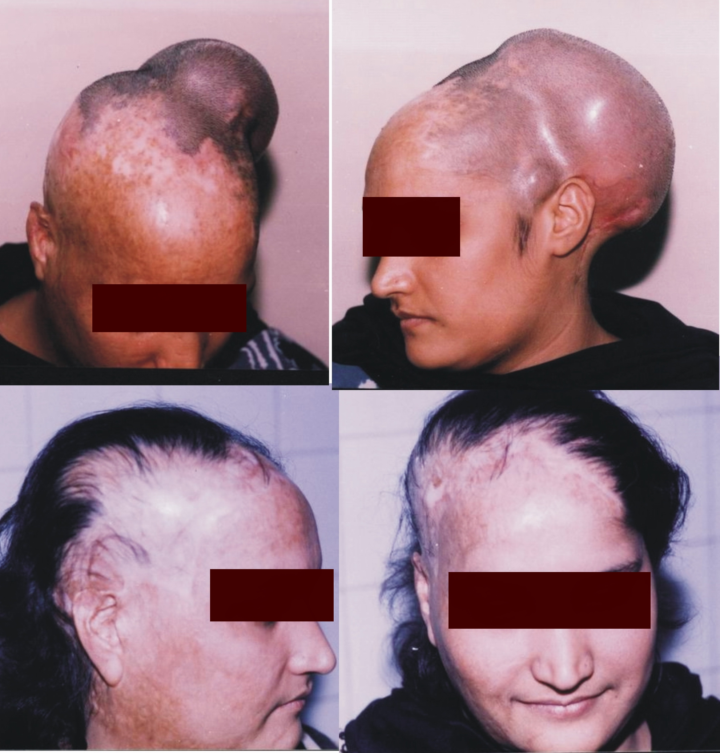
Figure 2 Pre-operative and post-operative case of post-burn alopecia.

reconstructed using the rotation flaps (Figure 2).
Discussion
Scalp is the second most visible part of human anatomy second to the face.¹¹ Tissue expansion is widely used in plastic and reconstructive surgery 2-4. It adds an extra armamentarium for the hair restorative surgeon. With the advances in surgical techniques, many of the hair restorative surgeons prefer to use hair transplantation instead of flap reconstruction especially using tissue expansion. The tissue expansion produces a mechanical stretch resulting in localized ischemia of the expanded skin and hence, promoting angiogenesis.¹² A conventional tissue expander is comprised of three basic parts, i) an elastic might silicone elastomer balloon, ii) a connecting tube, and iii) a self-sealing injection port. The tissue around expander reacts to form a ‘capsule’. This capsule has been demonstrated to have a circulation exceeding that of the subdermal plexus.¹³
Expanding the normal skin using tissue expanders has grown to become the method of choice for post-cicatricial alopecia in children with excellent results.^{11,14,15} A few case reports do mention the results of follicular unit transplantation in burn scars but the results depend on the density of the grafted area.^{16,17} The density in turn depends on various factors like vascularity of scar tissue, amount of the underlying fatty tissue and smoking.¹¹
However, even after the multiple sessions it might not be possible to obtain reasonable hair density. In these cases, the tissue expansion could provide an excellent alternative. Similarly in cases where skin grafts were placed to the cranium, there would be virtually no underlying soft tissue and follicular unit transplantation might not provide satisfactory or may result in the necrosis.¹¹ The tissue expansion poses many advantages. It provides hair bearing local skin for reconstruction. It also removes the defect (scar). The planning of the surgical procedure, volumes of tissue expanders and the knowledge of rotation flaps are of utmost value. The size and shape of tissue expanders depend on the defect and available tissue. The surgeon must be able to alter the surgical reconstruction process, e.g. the use of multiple tissue expanders allow the geometry of the flaps to be rotated easily. We used the trichophytic wound closure technique while suturing the flaps together. It allowed us a more natural closure and resulted in minimally visible scars through which the hair were growing out. In many case, we also scored the galea and capsule formed around the tissue expander which helped to gain some extra length of the flaps as well. In the patients in whom the resultant scar was visible on the forehead, we used follicular unit transplantation later to create a naturally-looking hairline.
Pain/discomfort during the expansion process was the most common complication noted especially in the later stages of expansion. No case of infection was noted. We used slightly filled tissue expanders in all the cases. It helped to produce an internal hemostatic effect resulting in low drain-fluid and reduction of infection to ‘zero’. In most of the cases we used rectangular, oval and crescent tissue expanders. A large series of 57 patients has been presented by Qing et al which showed a complication rate of 14%.¹⁸ Similarly, the study by Saleh et al.¹⁹ had 21.5% complication rate with 8.25% infection and 5% expander extrusion. None of these complications were seen in the present study. The other study by Zellwegar et al.²⁰ showed 22% complication rate as compared to the total complication rate of 0.6% in the current series. The lower complication rate (7%) was also seen in the study documented by Fan et al.²¹ in patients with moderate to major scalp defects (25% to 75%). El Sadat et al.²² have reported a new innovation using endoscopic approach for tissue expander placement in pediatric population, in an attempt to reduce the morbidity and complication rates.
Conclusion
Tissue expansion is a simple and safer technique to treat effectively the scar alopecia.
References
- Neumann C. The expansion of an area of skin by progressive distension of a subcutaneous balloon. J Plast Surg. 1957;19:124-6.
- Ahmad M. Tissue expansion; in reconstructive surgery. Professional Med J. 2011;14:611-15.
- Manders EK. Reconstruction using soft tissue expansion. In: Achauer BM, Erickson E, Guyuron B et al., eds. Plastic Surgery: Indications, Operations, and Outcomes. Philadelphia: Mosby; 2000. P. 201-35.
- McCauley RL. Tissue expansion reconstruction of the scalp. Seminars Plast Surg. 2005;19:143-52.
- Epstein JS. The role of tissue expansion in hair transplant surgery: Presentation of two unique cases. Hair Transpl Forum Intl. 2002;12:108-9.
- Epstein JS. Scalp reconstruction: the role of tissue expansion. Hair Transpl Forum Intl. 2006;16:171-2.
- Juri J, Juri C. The Juri flap. Facial Plast Surg. 1985;2:269-82.
- Unger MG. Scalp reductions. Facial Plast Surg. 1985;2:253-8.
- Leedy JE, Janis JE, Rohrich RJ. Reconstruction of acquired scalp defects: an algorithmic approach. Plast Reconstr Surg. 2005;116:54e-72e.
- Ahmad M, Mohmand MH. Tissue expansion and hair restoration. Hair Transpl Forum Intl. 2013;23.
- Elkafarawi HY, Goma’a RM, Aboueldahab AK. Minimizing the complications in hair restoration by tissue expansion for paediatric post-cicatricial alopecia. Egypt J Plast Reconstr Surg. 2013;37(1):97-100.
- Bilkay U, Kerem H, Ozek C et al. Alopecia treatment with scalp expansion: some surgical fine points and a simple modification to improve the results. J Craniofac Surg. 2004;15:758-65.
- Lantier L, Martin GN, Wechsler J. Vascular endothelial growth factor expression in expanded tissue: a possible mechanism of angiogenesis in tissue expansion. J Plast Surg. 1998;101:392-95.
- De Agustin JC, Morris SF, Zuker RM. Tissue expansion in pediatric burn reconstruction. J Burn Care Rehabil. 1993;14:43-50.
- Kolasinski J, Kolendra M. Algorithm of hair restoration surgery in children. Plast Reconstr Surg. 2003;112:412-22.
- Barrera A. The use of micrografts and minigrafts in the aesthetic reconstruction of the face and scalp. Plast Reconstr Surg. 2003;112:883-90.
- Marzola M. Alopecia reduction. In: Unger WP, Shapiro R, Unger M, Unger R, eds. Hair Transplantation, 5th ed. London: Informa Healthcare; 2010: 483-504.
- Qing Y, Cen Y, Liu Y. Prevention and treatment of postoperative complication after skin soft tissue expansion for scar alopecia. Zhongguo Xiu Fu Chong Jian Wai Ke Za Zhi. 2006;20:1193-95. Chinese.
- Saleh Y. Scalp reconstruction using tissue expander. Egypt J Plast Reconstr Surg. 2004;28:71-5.
- Zellweger G, Kunzi W. Tissue expanders in reconstruction of burn sequelae. Ann Plast Surg. 1991;26:380-8.
- Fan JC, Wang JP. Plastic surgical management of large cicatrical scalp alopecia. Zhonghua Yi Xue Za Zhi. 2009;89: 1098-1101. Chinese.
- El Sadat AM. Endoscopic approach for tissue expansion for different cosmetic lesions in pediatric age. Ann Pediatr Surg. 2010;6:27-33.

