PhotoDermDiagnosis
Multiple umbilicated papulonodular lesions in an immunocompetent lady
Satyendra Kumar Singh, Tulika Rai, Taniya Sharma, Anand Prabhu

Department of Dermatology and Venereology, Institute of Medical Sciences, Banaras Hindu University, Varanasi, India-221005

A 50-year-old woman, presented with multiple papulonodular lesions scattered on face, neck, chest and upper back. The lesions started on face and progressively involved the other parts affected over a span of forty-five days. There was mild burning and itching over the lesions.
On examination, multiple papular and nodular lesions were scattered on face, neck, chest and upper back. Many of them showed central umbilication. Few of the lesions showed crusting (Figure 1). There was no generalized lymphadenopathy, hepatosplenomegaly or any other detectable systemic abnormality. Liver function tests, renal function tests, complete blood count, chest x-ray, Mantoux test, ELISA for HIV and random blood sugar revealed no abnormality. Patient was not on any systemic immunosuppressive therapy. Histopathology of skin biopsy revealed dense tuberculoid granulomatous infiltrate made up of
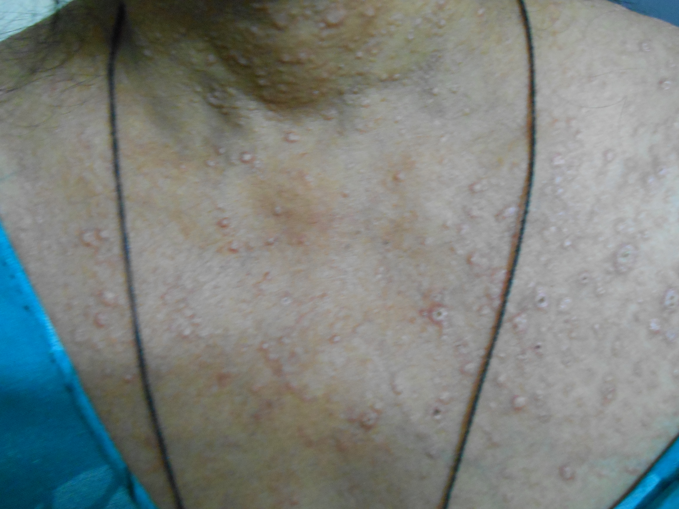
Figure 1 Umbilicated papulo-nodular lesions on neck and chest.
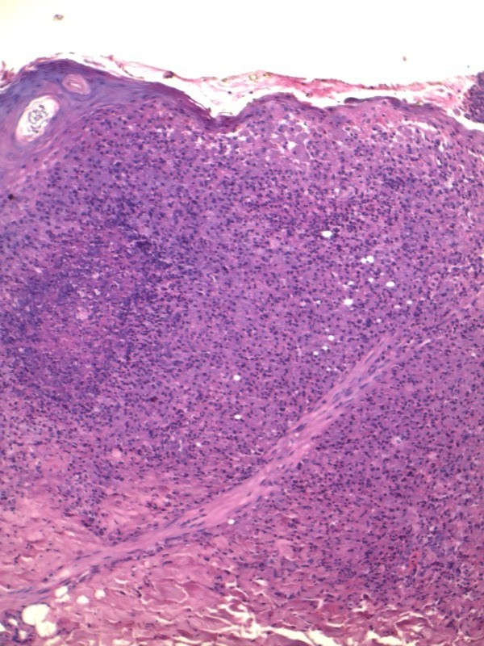
Figure 2 Histopathology showing dense tuberculoid granulomatous infiltrate made up of lymphocytes, plasma cells, histiocytes and epithelioid cells with occasional Langerhan's giant cells. Several histiocytes and giant cells showed numerous yeast cells of size 2 micron within their cytoplasm (hematoxylin and eosin X100).
lymphocytes, plasma cells, histiocytes and epithelioid cells with occasional Langerhan's giant cells. Several histiocytes and giant cells showed numerous yeast cells of size 2 micron within their cytoplasm (Figure 2).
What is the diagnosis?
Diagnosis
Primary cutaneous histoplasmosis in an immunocompetent patient.
Discussion
Histoplasmosis, also called as Darling's disease, is caused by a dimorphic fungus Histoplasma capsulatum.¹ The fungus has two variants viz. H. capsulatum var. capsulatum, which is found in America and the tropics, and H. capsulatum var. duboisii, which is found in Africa. H. capsulatum (the American form) mainly causes pulmonary involvement resembling tuberculosis and may pass asymptomatically to involve the reticuloendothelial system and the skin. H. duboisii mainly causes cutaneous and osseous involvement and is strictly restricted to the African continent.¹ The pulmonary and disseminated forms of histoplasmosis are very common in AIDS patients and cause great morbidity and mortality. Primary cutaneous histoplasmosis is rare.² H. capsulatum is an intracellular organism parasitizing the reticuloendothelial system and involving the spleen, liver, kidney, CNS and other organs. H. capsulatum exists as a saprophyte in nature and has been isolated from soil, particularly when contaminated with chicken feathers or droppings. Its spores are infectious to humans by the airborne route.¹
Histoplasmosis is rarely reported from India, perhaps on account of its varied clinical presentation and lack of awareness amongst dermatologists. Panja and Sen first reported histoplasmosis from India in 1959.³ Our patient showed widespread cutaneous lesions without any evidence of systemic involvement or immunosuppression. Histoplasmosis usually responds to itraconazole, fluconazole or amphotericin B.⁴ Our patient showed an excellent response to itraconazole 100 mg BD. The lesions started healing after six weeks of therapy and the patient is on follow-up and improving.
References
- Hay RJ, Moore M. Mycology. In: Champion RH, Burton JL, Burns DA, Breathnach SM, editors. Textbook of Dermatology. 6th ed. Oxford: Blackwell Science; 1998. p. 1363-6.
- Singhi MK, Gupta L, Kacchawa D, Gupta D. Disseminated primary cutaneous histoplasmosis successfully treated with itraconazole. Indian J Dermatol Venereol Leprol. 2003;69:405-7.
- Panja G, Sen S. A unique case of histoplasmosis. J Indian Med Assoc. 1959;23:257-8.
- Negroni R, Palmieri O, Koren F et al. Oral treatment of paracoccidioidomycosis and histoplasmosis with itraconazole in humans. Rev Infect Dis. 1987;9:S47-50.

