Case Report
Lymphangioma circumscriptum of buttock mimicking lupus vulgaris and responding with anti-tubercular chemotherapy
Shahid Hassan, Firdaus J, Neha R, Prabhat Kumar, D K Mishra, Shyam S Chaudhary

Department of Dermatology, Venereology and Leprosy, Rajendra Institute of Medical Sciences, Ranchi

Abstract | Lymphangioma circumscriptum (LC) is a form of lymphangioma involving skin and subcutaneous tissue. Circumscriptum as its name suggests, is a well-circumscribed small lesion but it has a rare extensive variety also. LC may resemble other entities such as metastatic carcinoma of skin, lymphangiectasis, syringocystadenoma papilliferum, lupus vulgaris, actinomycosis etc. It is a difficult condition to treat. Different modalities of treatment such as surgical excision, laser, sclerotherapy, radiofrequency coagulation are used to treat this condition. We report here clinical presentation mimicking lupus vulgaris and responding with anti-tubercular (ATT) chemotherapy.  Key words  Lymphangioma circumscriptum, anti-tubercular chemotherapy.

Introduction
Lymphangioma circumscriptum (LC) or microcystic lymphatic malformation is a hamartomatous malformation of the lymphatic channels of the skin. It represents sequestrated lymphatic vessels that have failed to link up with the rest of the lymphatic system or within the venous system during embryological development. Mulliken and colleagues who suggested the term ‘cystic lymphatic malformation’ as more appropriate than lymphangioma, subdivided lymphangioma into microcystic (lymphangioma, verrucous hemangioma and angiokeratoma circumscriptum) and macrocystic (cystic hygroma and cavernous hemangioma).¹ Lymphangioma circumscriptum is the term coined by Morris. It is characterized by clusters of thin walled vessels on the surface of the skin like frog spawn. LC may resemble a number of disorders including lymphangiosarcoma, syringocystadenoma papilliferum, lupus vulgaris, actinomycosis, herpes zoster, viral warts and molluscum contagiosum.² We report a case of mimicking lupus vulgaris and responding with ATT.
Address for correspondence
Dr. Shahid Hassan
180/C, Patliputra Colony
Patna, Bihar, India
Ph: 9431268820
E-mail: snrhassan@gmail.com
Case report
A 13-year-old boy presented with red brown plaque on buttock composed of nodules showing apple-jelly appearance on diascopy. The disease was chronic since five years and progressive. On examination there was a large plaque on left side of the buttock studded with nodules of varying size (Figure 1). Rest of the cutaneous and systemic examination was unremarkable.
A clinical diagnosis of lupus vulgaris was initially made, as this disease is endemic here and patient was put on oral anti-tubercular therapy (rifampicin 225 mg, isoniazid 150 mg, pyrazinamide 750 mg, ethambutol 400 mg). After completion of ATT the lesion subsided and only a few papular lesions were present. After 3-4 months of completion of treatment,
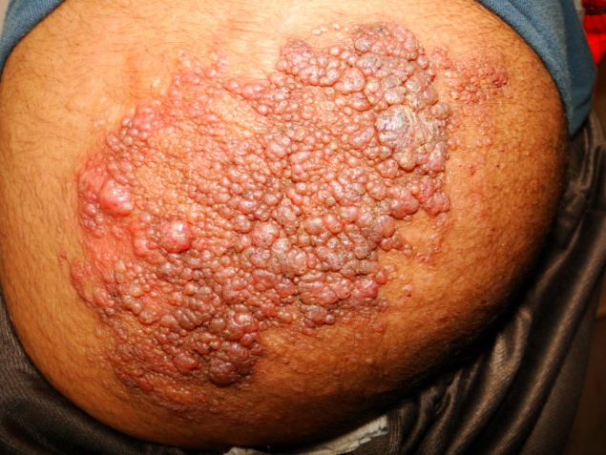
Figure 4 Initial lesion.

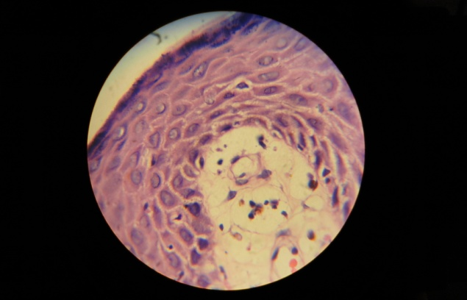
Figure 2 40x zoom dilatation of dermal papilla and thinning of overlying epidermis.

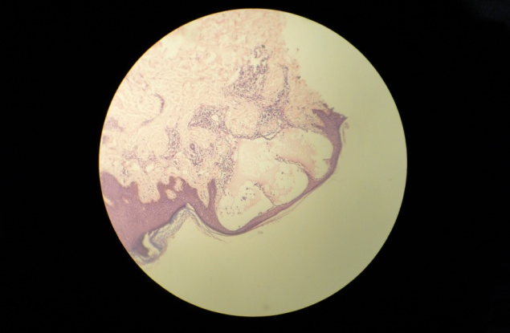
Figure 3 10x zoom several markedly dilated lymphatic channels incompletely lined by a single layer of endothelium.

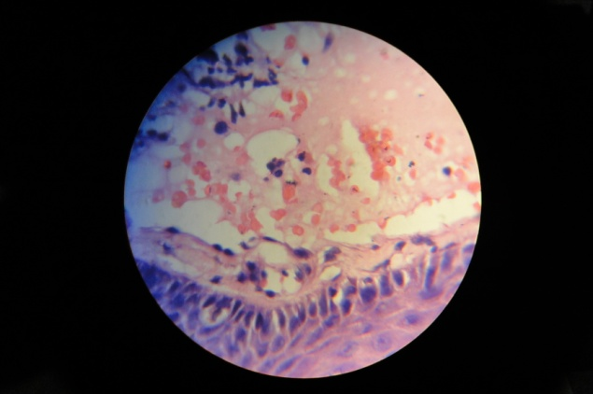
Figure 4 40x zoom channel contains lymph with admixture of RBCs.
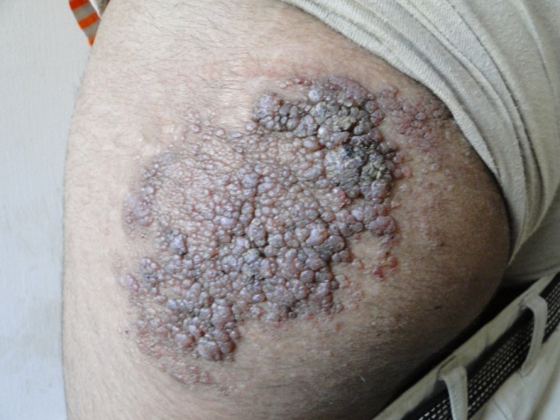
Figure 5 After 2 months of treatment.
the lesion started spreading in size again. Polymerase chain reaction (PCR) for TB was negative. Hence skin biopsy was performed.
Microscopic examination showed dilatation of some of the dermal papillae and thinning of overlying epidermis (Figure 2). The dilated papillae showed several markedly dilated lymphatic channels incompletely lined by a single layer of endothelium (Figure 3). The channels contained lymph with slight admixture of RBCs (Figure 4). A few dilated thick walled lymphatics could be seen in deep reticular dermis. Rest of the epidermis showed a sparse perivascular lymphocytic infiltration. A final diagnosis of lymphangioma circumscriptum was made on the basis of histopathological findings.
To check if ATT was effective in LC or not we again decided to put patient on ATT (four drug regimen) again. Size of the lesion again started to decrease (Figure 5).
Discussion
A lymphangioma or lymphatic malformation represents a congenital proliferation of lymphatic vessels. These conditions account for approximately 4 percent of vascular tumours and 26 percent of benign vascular tumours in children.
It was initially described as lymphangiectoides in 1879 by Tilbury Fox and Colcott Fox. It was named lymphangioma circumscriptum by Morris in 1889. Clinical findings consist of multiple, clear vessels that may be pink, red or black owing to serosanguinous fluid and hemorrhage. These vesicles contain lymph fluid and are often said to resemble frogspawn. Most commonly, LC is found on proximal extremities, trunk, axilla and oral cavity but may also occur on the penis, vulva and scrotum.³
In 1970, Peachy et al. divided LC in two main groups, classical and localized. Classical form of LC is typically seen at or soon after birth, is often larger than 1 cm². Localized form is seen at any age, is often less than 1 cm², and may appear anywhere on body.⁴
The pathogenesis of LC was first described by Whimster in 1976.⁵ He postulated that lymphatic cisterns in the deep subcutaneous tissue arise from early lymph tissue sacs during embryonic development. Furthermore he noted that these sacs were distinct entities that did not connect to the remainder of lymphatic system.
Indication of treatment of LC includes both cosmetic repair and prevention of complications such as cellulitis.
There is currently no proven medical cure of LC. The definitive treatment of lymphangioma is surgical excision of both the superficial and deep component. However, the recurrence rate can be high. Other treatments that have been reported include superficial X-ray therapy, radiotherapy, argon laser, CO₂ laser, pulsed dye laser and sclerotherapy.
We decided to put the patient on ATT again as there was substantial improvement noted earlier by patient, attendants and by documentation. We again noted the decrease in size of overall lesion as well as decrease in size of the individual lymphatic papules.
Conclusion
As there is no proven medical care of LC. The ATT has shown substantial improvement in our case. Further research and trials are needed to confirm improvement and to know which molecule in ATT acts on lymphangioma circumscriptum.
References
- Mulliken JB, Young A, eds. Vascular Birthmarks, Hemangiomas and Vascular Malformations. Philadelphia: WB Saunders; 1988.
- Kura MK, Rane VK. Cervicofacial actinomycosis mimicking lymphangioma circumscriptum – a case report. Indian J Dermatol. 2011;56:321-3.
- Abu-Hamad A, Provencher D, Ganjee P, Penaher M. Lymphangioma circumscriptum of vulva; a case report and review of literature. Obstet Gynecol. 1989;73:262-3.
- Peachey RD, Lim CC, Whimster IW. Lymphangioma of skin. A review of 65 cases. Br J Dermatol. 1970;83:519-27.
- Whimster IW. The pathology of lymphangioma circumscriptum. Br J Dermatol. 1976;94:473-86.

